|  |  |
| --- | --- |
| **Intelligent Systems** | |
| **Project 1** | |
| **Name** | Student Id |
| **Nilanjan Mhatre** | 801045013 |
| **Akash Raghuvanshi** | 801043608 |

**8-puzzle Formulation**

The 8-puzzle problem is a puzzle played on a 3-by-3 grid with 8 square blocks labelled 1 - 8 and a blank square. The goal is to rearrange the blocks in the initial state so that they are in the order specified by goal state. The blocks are permitted to slide horizontally or vertically into the blank square.

A* algorithm is a state space search algorithm which integrates characteristics of uniform-cost search and heuristic-based search to proficiently find the optimally efficient path.

The A* algorithm aims at using the heuristic as well as the distance travelled so far, combined to select the nodes from the fringe. For 8 puzzle problem, it uses two types of heuristic to find the shortest path to goal state i.e.

* Number of misplaced tiles: The count of tiles that are not present in its desired positions.
* Manhattan distance: It is the linear distance the tile must cover from the initial position to reach the goal position.

The below code aims at implementing A* algorithm using the above-defined heuristic functions to find the optimal path from user provided initial state to user provided goal state.

**Program running instructions**

* Import in eclipse or IntelliJ
* Run AStar.java

OR

* Go to src>project
* Open command line here (configure java in environment variables)
* Run following commands
* javac -d ./ .\Puzzle8.java .\AStar.java
* java project.AStar

**Program Structure**

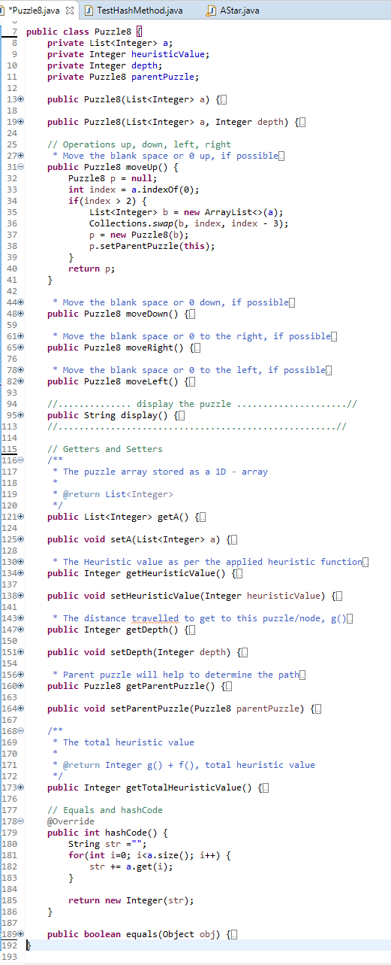

1. An **instance** of class ‘Puzzle8’ stores a particular **state**, along with its heuristic value (h), the distance/depth travelled (g) to get to that state and the parent ‘Puzzle8’.
2. The array ‘a’ defines the number arrangement as a 1D array.

e.g. a= {1, 2, 3, 4, 5, 6, 7, 8, 0}

implies $\left[\begin{aligned}1 2 3 \\ 4 5 6 \\ 7 8-\end{aligned}\right]$

1. ‘**hashCode’** method returns ‘**hash**’ of every state, which would be unique for each state of all 9! i.e. 362880 combinations possible (Checked using **TestHashMethod.java**). This value will be used to store states that were already **visited** in the A-star algorithm, rather than storing the whole ‘Puzzle8’ object or the array
2. ‘equals’ method uses ‘hashCode’ rather than comparing for every array element
3. **Operations** include moving blank space - **up**, **down**, **right** or **left**. The operation will return a new instance of ‘Puzzle8’, which would have the parent as the current instance
4. Correct logic is applied for each of the operations while dealing with a 1D representation
5. E.g. Up operation swaps the ‘blank’ at (position) with the element at (position – 3)
6. If the operation is not possible, null is returned

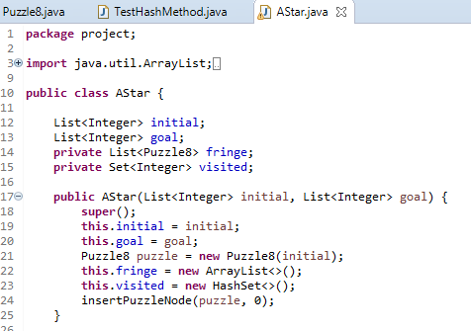

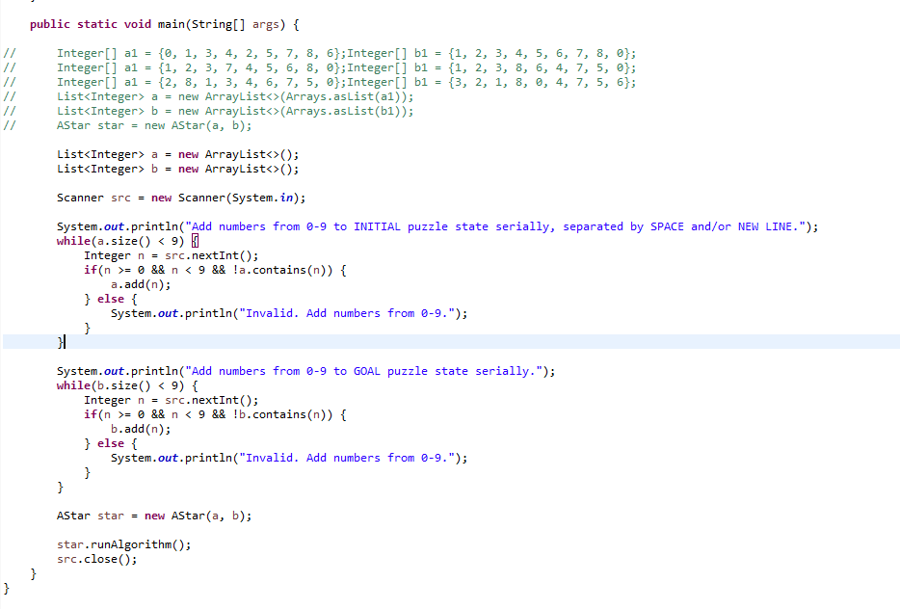

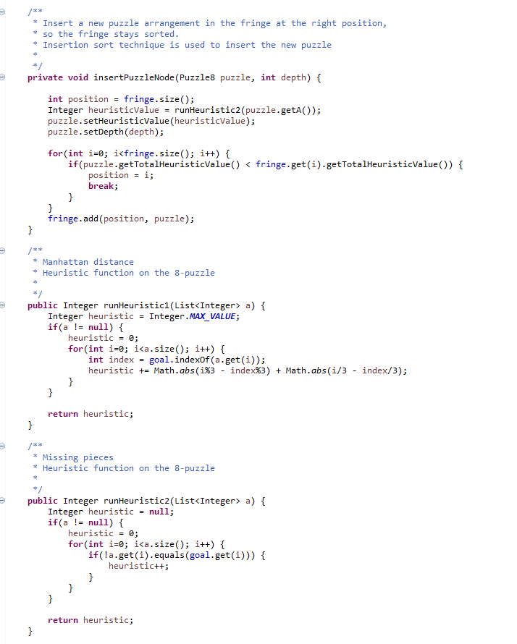

1. ‘Astar’ class instance will take the **initial** and the **goal** state
2. A ‘**fringe’** of puzzles will be created, that will include the initial state already present
3. Again, the states are 1D arrays, represented for the 8-puzzle problem, to improve performance by keeping minimal references
4. User input will be taken as initial and goal state
5. ‘**insertPuzzleNode**’ inserts every expanded node/state to the fringe
6. ‘**Insertion sort**’ technique is used to determine the right position to insert the new puzzle based on

‘totalHeuristic=(g)+(h)’

1. Two heuristic functions are defined, that is called in ‘insertPuzzleNode’
2. ‘runHeuristic1’ is **Manhattan distance**

“Formula for 1D array =

abs|index%3 - correctIndex%3| +

abs|index/3 - correctIndex/3|”

1. ‘runHeuristic2’ is **Misplaced tiles**

The formula for 1D array

=(counter++) for every mismatched index

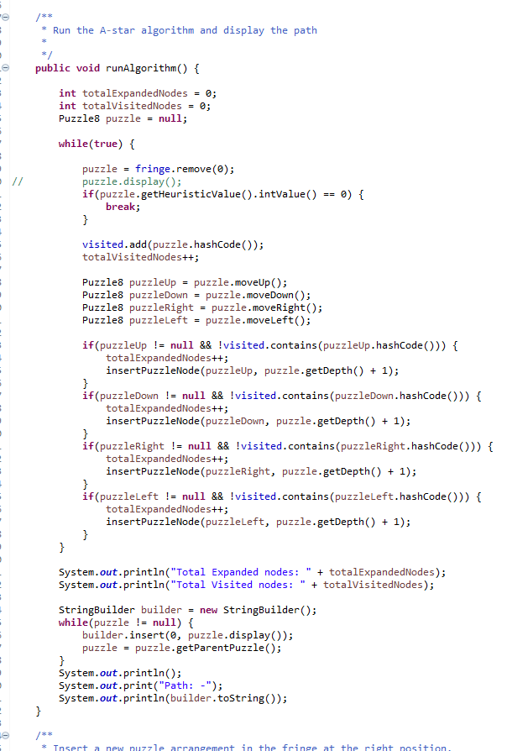

Algorithm: -

1. The loop breaks when the ‘**heuristic value**’ equals 0
2. The ‘**fringe**’ is always sorted as the sorting is carried while inserting
3. Hence, the least heuristic node/puzzle is at the 0th index
4. Add its ‘hashCode’ to the ‘**visited**’ list and increment ‘totalVisited’ counter
5. If it is not the goal, **expand** to generate more nodes by performing operations – **up**, **down**, **right**, **left**, whichever is possible, and add the generated nodes/puzzles to the fringe by insert operation maintaining the sorting
6. Increment the ‘totalExpanded’ counter
7. When the loop breaks, the ‘puzzle’ object will contain the goal state
8. **Trace** **the complete path by ‘parentPuzzle’ link**

**Sample results for Misplaced Tile Heuristics**

Add numbers from 0-9 to INITIAL puzzle state serially, separated by SPACE and/or NEW LINE.

0 1 3 4 2 5 7 8 6

Add numbers from 0-9 to GOAL puzzle state serially.

1 2 3 4 5 6 7 8 0

Total Expanded nodes: 9

Total Visited nodes: 4

Path: -

_ 1 3

4 2 5

7 8 6

1 _ 3

4 2 5

7 8 6

1 2 3

4 _ 5

7 8 6

1 2 3

4 5 _

7 8 6

1 2 3

4 5 6

7 8 _

Process finished with exit code 0

********************************************************

Add numbers from 0-9 to INITIAL puzzle state serially, separated by SPACE and/or NEW LINE.

1 2 3 7 4 5 6 8 0

Add numbers from 0-9 to GOAL puzzle state serially.

1 2 3 8 6 4 7 5 0

Total Expanded nodes: 43

Total Visited nodes: 23

Path: -

1 2 3

7 4 5

6 8 _

1 2 3

7 4 _

6 8 5

1 2 3

7 _ 4

6 8 5

1 2 3

7 8 4

6 _ 5

1 2 3

7 8 4

_ 6 5

1 2 3

_ 8 4

7 6 5

1 2 3

8 _ 4

7 6 5

1 2 3

8 6 4

7 _ 5

1 2 3

8 6 4

7 5 _

Process finished with exit code 0

********************************************************

Add numbers from 0-9 to INITIAL puzzle state serially, separated by SPACE and/or NEW LINE.

2 8 1 3 4 6 7 5 0

Add numbers from 0-9 to GOAL puzzle state serially.

3 2 1 8 0 4 7 5 6

Total Expanded nodes: 14

Total Visited nodes: 7

Path: -

2 8 1

3 4 6

7 5 _

2 8 1

3 4 _

7 5 6

2 8 1

3 _ 4

7 5 6

2 _ 1

3 8 4

7 5 6

_ 2 1

3 8 4

7 5 6

3 2 1

_ 8 4

7 5 6

3 2 1

8 _ 4

7 5 6

Process finished with exit code 0

********************************************************

Add numbers from 0-9 to INITIAL puzzle state serially, separated by SPACE and/or NEW LINE.

2 8 3 1 6 4 7 0 5

Add numbers from 0-9 to GOAL puzzle state serially.

1 2 3 8 0 4 7 6 5

Total Expanded nodes: 13

Total Visited nodes: 6

Path: -

2 8 3

1 6 4

7 _ 5

2 8 3

1 _ 4

7 6 5

2 _ 3

1 8 4

7 6 5

_ 2 3

1 8 4

7 6 5

1 2 3

_ 8 4

7 6 5

1 2 3

8 _ 4

7 6 5

Process finished with exit code 0

********************************************************

Add numbers from 0-9 to INITIAL puzzle state serially, separated by SPACE and/or NEW LINE.

8 1 3 4 0 2 7 6 5

Add numbers from 0-9 to GOAL puzzle state serially.

1 2 3 4 5 6 7 8 0

Total Expanded nodes: 555

Total Visited nodes: 338

Path: -

8 1 3

4 _ 2

7 6 5

8 1 3

4 2 _

7 6 5

8 1 3

4 2 5

7 6 _

8 1 3

4 2 5

7 _ 6

8 1 3

4 2 5

_ 7 6

8 1 3

_ 2 5

4 7 6

_ 1 3

8 2 5

4 7 6

1 _ 3

8 2 5

4 7 6

1 2 3

8 _ 5

4 7 6

1 2 3

_ 8 5

4 7 6

1 2 3

4 8 5

_ 7 6

1 2 3

4 8 5

7 _ 6

1 2 3

4 _ 5

7 8 6

1 2 3

4 5 _

7 8 6

1 2 3

4 5 6

7 8 _

Process finished with exit code 0

********************************************************

Add numbers from 0-9 to INITIAL puzzle state serially, separated by SPACE and/or NEW LINE.

7 2 4 5 0 6 8 3 1

Add numbers from 0-9 to GOAL puzzle state serially.

1 2 3 4 5 6 7 8 0

Total Expanded nodes: 6790

Total Visited nodes: 4286

Path: -

7 2 4

5 _ 6

8 3 1

7 2 4

5 3 6

8 _ 1

7 2 4

5 3 6

8 1 _

7 2 4

5 3 _

8 1 6

7 2 4

5 _ 3

8 1 6

7 2 4

_ 5 3

8 1 6

_ 2 4

7 5 3

8 1 6

2 _ 4

7 5 3

8 1 6

2 4 _

7 5 3

8 1 6

2 4 3

7 5 _

8 1 6

2 4 3

7 _ 5

8 1 6

2 4 3

7 1 5

8 _ 6

2 4 3

7 1 5

_ 8 6

2 4 3

_ 1 5

7 8 6

2 4 3

1 _ 5

7 8 6

2 _ 3

1 4 5

7 8 6

_ 2 3

1 4 5

7 8 6

1 2 3

_ 4 5

7 8 6

1 2 3

4 _ 5

7 8 6

1 2 3

4 5 _

7 8 6

1 2 3

4 5 6

7 8 _

Process finished with exit code 0

********************************************************

Add numbers from 0-9 to INITIAL puzzle state serially, separated by SPACE and/or NEW LINE.

1 2 0 4 5 3 7 8 6

Add numbers from 0-9 to GOAL puzzle state serially.

1 2 3 4 5 6 7 8 0

Total Expanded nodes: 4

Total Visited nodes: 2

Path: -

1 2 _

4 5 3

7 8 6

1 2 3

4 5 _

7 8 6

1 2 3

4 5 6

7 8 _

Process finished with exit code 0

********************************************************

Add numbers from 0-9 to INITIAL puzzle state serially, separated by SPACE and/or NEW LINE.

1 2 3 0 4 6 7 5 8

Add numbers from 0-9 to GOAL puzzle state serially.

1 2 3 4 5 6 7 8 0

Total Expanded nodes: 8

Total Visited nodes: 3

Path: -

1 2 3

_ 4 6

7 5 8

1 2 3

4 _ 6

7 5 8

1 2 3

4 5 6

7 _ 8

1 2 3

4 5 6

7 8 _

Process finished with exit code 0

********************************************************

Add numbers from 0-9 to INITIAL puzzle state serially, separated by SPACE and/or NEW LINE.

3 8 2 4 5 6 1 7 0

Add numbers from 0-9 to GOAL puzzle state serially.

1 2 3 4 5 6 7 8 0

Total Expanded nodes: 14780

Total Visited nodes: 9385

Path: -

3 8 2

4 5 6

1 7 _

3 8 2

4 5 _

1 7 6

3 8 2

4 _ 5

1 7 6

3 8 2

_ 4 5

1 7 6

3 8 2

1 4 5

_ 7 6

3 8 2

1 4 5

7 _ 6

3 8 2

1 4 5

7 6 _

3 8 2

1 4 _

7 6 5

3 8 _

1 4 2

7 6 5

3 _ 8

1 4 2

7 6 5

_ 3 8

1 4 2

7 6 5

1 3 8

_ 4 2

7 6 5

1 3 8

4 _ 2

7 6 5

1 3 8

4 2 _

7 6 5

1 3 _

4 2 8

7 6 5

1 _ 3

4 2 8

7 6 5

1 2 3

4 _ 8

7 6 5

1 2 3

4 6 8

7 _ 5

1 2 3

4 6 8

7 5 _

1 2 3

4 6 _

7 5 8

1 2 3

4 _ 6

7 5 8

1 2 3

4 5 6

7 _ 8

1 2 3

4 5 6

7 8 _

Process finished with exit code 0

********************************************************

**Sample Solution for Manhattan distance heuristics**

Add numbers from 0-9 to INITIAL puzzle state serially, separated by SPACE and/or NEW LINE.

0 1 3

4 2 5

7 8 6

Add numbers from 0-9 to GOAL puzzle state serially.

1 2 3

4 5 6

7 8 0

Total Expanded nodes: 9

Total Visited nodes: 4

Path: -

_ 1 3

4 2 5

7 8 6

1 _ 3

4 2 5

7 8 6

1 2 3

4 _ 5

7 8 6

1 2 3

4 5 _

7 8 6

1 2 3

4 5 6

7 8 _

Process finished with exit code 0

********************************************************

Add numbers from 0-9 to INITIAL puzzle state serially, separated by SPACE and/or NEW LINE.

1 2 3

7 4 5

6 8 0

Add numbers from 0-9 to GOAL puzzle state serially.

1 2 3 8 6

4 7 5 0

Total Expanded nodes: 22

Total Visited nodes: 11

Path: -

1 2 3

7 4 5

6 8 _

1 2 3

7 4 _

6 8 5

1 2 3

7 _ 4

6 8 5

1 2 3

7 8 4

6 _ 5

1 2 3

7 8 4

_ 6 5

1 2 3

_ 8 4

7 6 5

1 2 3

8 _ 4

7 6 5

1 2 3

8 6 4

7 _ 5

1 2 3

8 6 4

7 5 _

Process finished with exit code 0

********************************************************

Add numbers from 0-9 to INITIAL puzzle state serially, separated by SPACE and/or NEW LINE.

2 8 1 3 4 6 7 5 0

Add numbers from 0-9 to GOAL puzzle state serially.

3 2 1 8 0 4 7 5 6

Total Expanded nodes: 12

Total Visited nodes: 6

Path: -

2 8 1

3 4 6

7 5 _

2 8 1

3 4 _

7 5 6

2 8 1

3 _ 4

7 5 6

2 _ 1

3 8 4

7 5 6

_ 2 1

3 8 4

7 5 6

3 2 1

_ 8 4

7 5 6

3 2 1

8 _ 4

7 5 6

Process finished with exit code 0

********************************************************

Add numbers from 0-9 to INITIAL puzzle state serially, separated by SPACE and/or NEW LINE.

8 1 3 4 0 2 7 6 5

Add numbers from 0-9 to GOAL puzzle state serially.

1 2 3 4 5 6 7 8 0

Total Expanded nodes: 187

Total Visited nodes: 110

Path: -

8 1 3

4 _ 2

7 6 5

8 1 3

4 2 _

7 6 5

8 1 3

4 2 5

7 6 _

8 1 3

4 2 5

7 _ 6

8 1 3

4 2 5

_ 7 6

8 1 3

_ 2 5

4 7 6

_ 1 3

8 2 5

4 7 6

1 _ 3

8 2 5

4 7 6

1 2 3

8 _ 5

4 7 6

1 2 3

_ 8 5

4 7 6

1 2 3

4 8 5

_ 7 6

1 2 3

4 8 5

7 _ 6

1 2 3

4 _ 5

7 8 6

1 2 3

4 5 _

7 8 6

1 2 3

4 5 6

7 8 _

Process finished with exit code 0

********************************************************

Add numbers from 0-9 to INITIAL puzzle state serially, separated by SPACE and/or NEW LINE.

2 8 3 1 6 4 7 0 5

Add numbers from 0-9 to GOAL puzzle state serially.

1 2 3 8 0 4 7 6 5

Total Expanded nodes: 11

Total Visited nodes: 5

Path: -

2 8 3

1 6 4

7 _ 5

2 8 3

1 _ 4

7 6 5

2 _ 3

1 8 4

7 6 5

_ 2 3

1 8 4

7 6 5

1 2 3

_ 8 4

7 6 5

1 2 3

8 _ 4

7 6 5

Process finished with exit code 0

********************************************************

Add numbers from 0-9 to INITIAL puzzle state serially, separated by SPACE and/or NEW LINE.

7 2 4 5 0 6 8 3 1

Add numbers from 0-9 to GOAL puzzle state serially.

1 2 3 4 5 6 7 8 0

Total Expanded nodes: 746

Total Visited nodes: 460

Path: -

7 2 4

5 _ 6

8 3 1

7 2 4

5 3 6

8 _ 1

7 2 4

5 3 6

8 1 _

7 2 4

5 3 _

8 1 6

7 2 4

5 _ 3

8 1 6

7 2 4

_ 5 3

8 1 6

_ 2 4

7 5 3

8 1 6

2 _ 4

7 5 3

8 1 6

2 4 _

7 5 3

8 1 6

2 4 3

7 5 _

8 1 6

2 4 3

7 _ 5

8 1 6

2 4 3

7 1 5

8 _ 6

2 4 3

7 1 5

_ 8 6

2 4 3

_ 1 5

7 8 6

2 4 3

1 _ 5

7 8 6

2 _ 3

1 4 5

7 8 6

_ 2 3

1 4 5

7 8 6

1 2 3

_ 4 5

7 8 6

1 2 3

4 _ 5

7 8 6

1 2 3

4 5 _

7 8 6

1 2 3

4 5 6

7 8 _

Process finished with exit code 0

********************************************************

Add numbers from 0-9 to INITIAL puzzle state serially, separated by SPACE and/or NEW LINE.

1 2 0 4 5 3 7 8 6

Add numbers from 0-9 to GOAL puzzle state serially.

1 2 3 4 5 6 7 8 0

Total Expanded nodes: 4

Total Visited nodes: 2

Path: -

1 2 _

4 5 3

7 8 6

1 2 3

4 5 _

7 8 6

1 2 3

4 5 6

7 8 _

Process finished with exit code 0

********************************************************

Add numbers from 0-9 to INITIAL puzzle state serially, separated by SPACE and/or NEW LINE.

1 2 3 0 4 6 7 5 8

Add numbers from 0-9 to GOAL puzzle state serially.

1 2 3 4 5 6 7 8 0

Total Expanded nodes: 8

Total Visited nodes: 3

Path: -

1 2 3

_ 4 6

7 5 8

1 2 3

4 _ 6

7 5 8

1 2 3

4 5 6

7 _ 8

1 2 3

4 5 6

7 8 _

Process finished with exit code 0

********************************************************

Add numbers from 0-9 to INITIAL puzzle state serially, separated by SPACE and/or NEW LINE.

3 8 2 4 5 6 1 7 0

Add numbers from 0-9 to GOAL puzzle state serially.

1 2 3 4 5 6 7 8 0

Total Expanded nodes: 2881

Total Visited nodes: 1789

Path: -

3 8 2

4 5 6

1 7 _

3 8 2

4 5 _

1 7 6

3 8 2

4 _ 5

1 7 6

3 8 2

_ 4 5

1 7 6

3 8 2

1 4 5

_ 7 6

3 8 2

1 4 5

7 _ 6

3 8 2

1 4 5

7 6 _

3 8 2

1 4 _

7 6 5

3 8 _

1 4 2

7 6 5

3 _ 8

1 4 2

7 6 5

_ 3 8

1 4 2

7 6 5

1 3 8

_ 4 2

7 6 5

1 3 8

4 _ 2

7 6 5

1 3 8

4 2 _

7 6 5

1 3 _

4 2 8

7 6 5

1 _ 3

4 2 8

7 6 5

1 2 3

4 _ 8

7 6 5

1 2 3

4 6 8

7 _ 5

1 2 3

4 6 8

7 5 _

1 2 3

4 6 _

7 5 8

1 2 3

4 _ 6

7 5 8

1 2 3

4 5 6

7 _ 8

1 2 3

4 5 6

7 8 _

Process finished with exit code 0